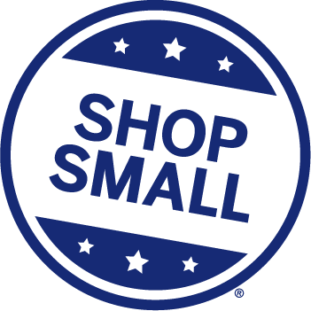
The Darlington Downtown Revitalization Association (DDRA) will hold a Shop Small Downtown Open House on Thursday, November 21, from 5 to 8 p.m. in partnership with American Express and Darlington Area Recreation.
We will have Pictures with Santa, Music, Vendors, and a Snow Machine on the Public Square. The first 200 guests will receive a Shop Small tote bag filled with goodies.
We want you to participate! Here’s how!
- Stay open until 8 o’clock on Thursday, Nov. 21. Provide small refreshments like cookies or candy, specials, contests, or coupons for that evening. The DDRA will have a map of businesses who are participating at the Square to hand out to attendees.
- Provide a Kids’ Activity. Inside or outside your business, have a space for kids to color or do a small Christmas craft to give parents a better chance to shop. These can be simple coloring sheets or something more elaborate, geared toward your specialty.
- Have a Vendor Booth on the Courthouse Grounds. This booth can be informational providing menus or pamphlets, more fun providing an activity for the kids, or more business where you can sell items. This is mainly for shops not located in the town center but open to all.
- Donate a Giveaway Item. We would like to feature a drawing or scavenger hunt game at this event, but we need PRIZES to do so. Donate by Thanksgiving.
- Provide Items to Distribute in the Shop Small Totes. These can be coupons, menus, business cards, or other flyers. If you want the DDRA to print or create flyers, contact us. We need items by Nov. 8.

Questions? Let us know ASAP if you want to participate!
Call Lisa Rock at 843-398-4000 x 103 or 843-992-1561
or email info@buildupdarlington.org

